Ideation Phase
Define the Problem Statements

Date | 04 July 2026
Team ID
Project Name | Personalised Networking Assistant
Maximum Marks | 2 Marks

Customer Problem Statement
Many people find it difficult to start meaningful conversations and build professional connections during networking events. They often lack confidence, relevant discussion topics, and reliable information. Our Personalized Networking Assistant addresses this problem by generating personalized conversation topics, providing fact-checked information, and helping users network more effectively.
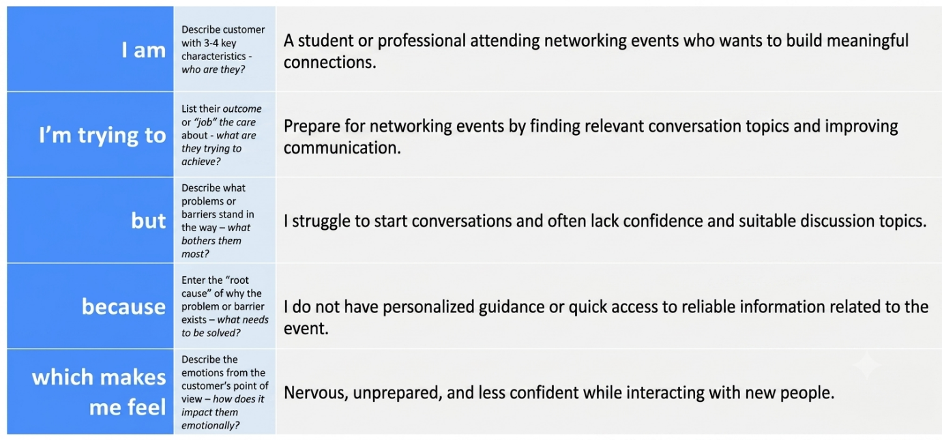

Example:
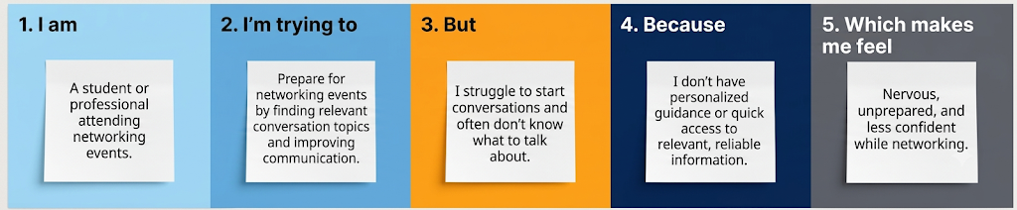
Problem Statement (PS) | I am (Customer) | I’m trying to | But | Because | Which makes me feel
PS-1 | A student attending networking events | Prepare for networking events and start meaningful conversation | I don't know how to begin conversations | I lack personalized guidance and relevant topics | Nervous and unprepared
PS-2 | A young professional attending conferences | Build professional connections and expand my network | I find it difficult to keep conversations engaging | I don't have quick access to reliable information or conversation ideas | Less confident and frustrated

